Kgaladi Tumiso Sekgoka & Cornelius Eromosele

ST10262964 & ST10302040

IIE MSA

SCHOOL OF INFORMATION TECHNOLOGY  
Group 4

WEB DEVELOPMENT (INTERMEDIATE) WEDE6021

POE Part 2

Contents

Table of Figures ii

Database clothingstore 1

Table structure for table tbladmin 1

Dumping data for table tbladmin 1

Table structure for table tblclothes 2

Dumping data for table tblclothes 2

Table structure for table tblmessages 5

Table structure for table tblorder 6

Dumping data for table tblorder 6

Table structure for table tblorderitems 8

Table structure for table tblorders 9

Dumping data for table tblorders 9

Table structure for table tblseller 10

Dumping data for table tblseller 10

Table structure for table tbluser 12

Dumping data for table tbluser 12

# Table of Figures

Figure 1:Table Structure of tblAdmin 1

Figure 2:Table Structure of tblClothes 4

Figure 3:Table Structure of tblMessages 5

Figure 4: :Table Structure of tblOrder 7

Figure 5: Table Structure of tblOrderItems 8

Figure 6: Table Structure of tblOrders 9

Figure 7: Table Structure of tblSeller 10

Figure 8:Table Structure of tblUser 14

# Database clothingstore

## Table structure for table tbladmin

|  |  |  |  |
| --- | --- | --- | --- |
| **Column** | **Type** | **Null** | **Default** |
| ***AdminID*** | int(11) | No |  |
| Name | varchar(100) | Yes | NULL |
| Email | varchar(100) | Yes | NULL |
| PasswordHash | varchar(255) | Yes | NULL |

## Dumping data for table tbladmin

|  |  |  |  |
| --- | --- | --- | --- |
| 1 | Tumiso | kgaladisekgoka@gmail.com | $2y$10$M4TZVpFKRc09Ba7vSP/pR.CGMOD.9NWzdtjOq.4teN1Cn2hG15Tz. |
| 2 | Alice Johnson | alice.johnson@example.com | $2y$10$NQv3IvRnrqQwImKVfo8Pje/ihERFUw8Fyd4bFZCUL.K7/ewJ73AJK |
| 3 | Bob Smith | bob.smith@example.com | $2y$10$f0GZW2nXcEegDg8xZ0akg.Iq6J6SKsdzrwMJsc4k682GABOTZa3SW |
| 4 | Charlie Brown | charlie.brown@example.com | $2y$10$K1Ux3Y8RDnbnYoJffCMGrOS5s/Jw.6z/oPakxDHznMT1ZkF2DK3xm |
| 5 | Diana Prince | diana.prince@example.com | $2y$10$UOykdZcxL.tWLDDHNvOcue6p7oTn7fgpTC529tVkLn3ukFXD3e3L2 |

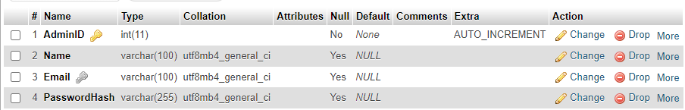

Figure 1:Table Structure of tblAdmin

## Table structure for table tblclothes

|  |  |  |  |
| --- | --- | --- | --- |
| **Column** | **Type** | **Null** | **Default** |
| ***ClothesID*** | int(11) | No |  |
| SellerID | int(11) | Yes | NULL |
| Name | varchar(100) | Yes | NULL |
| Price | decimal(10,2) | Yes | NULL |
| Quantity | int(11) | Yes | NULL |
| Description | text | Yes | NULL |
| ImagePath | varchar(255) | Yes | NULL |
| Brand | varchar(50) | Yes | NULL |
| Sizes | varchar(50) | Yes | NULL |
| Category | varchar(255) | Yes | NULL |

## Dumping data for table tblclothes

|  |  |  |  |  |  |  |  |  |  |
| --- | --- | --- | --- | --- | --- | --- | --- | --- | --- |
| 1 | 1 | Beige Women Coat | 899.99 | 4 | A stylish beige coat perfect for women during the fall season. | _images/beige_women_coat.jpg | Fashionista | S, M, L | Women |
| 2 | 2 | Black Dress | 499.99 | 14 | An elegant black dress suitable for evening occasions. | _images/black_dress.jpg | Elegant Wear | S, M, L, XL | Women |
| 3 | 3 | Blue Dress | 599.99 | 8 | A beautiful blue dress that flows gracefully for any event. | _images/blue_dress.jpg | Dress Co. | S, M, L | Women |
| 4 | 4 | Long Shirt | 299.99 | 8 | A casual long shirt perfect for layering or wearing alone. | _images/long_shirt.jpg | Casual Line | M, L, XL | Men |
| 5 | 5 | T-Shirt | 199.99 | 25 | A comfortable t-shirt for everyday wear. | _images/t_shirt.jpg | Everyday Wear | S, M, L, XL | Men |
| 6 | 1 | Pink Linen Outfit | 999.99 | 7 | Elegant pink linen outfit perfect for warm weather. | _images/pink_coat.jpg | Fashionista | S, M, L | Women |
| 7 | 2 | Everyday Explorer Alphabet Set | 299.99 | 10 | Childrens Casual Outfit Set, 2-Piece Set | _images/kids_casual_outfit.png | Carters | 7, 8, 9, 10, 11, 12, 13, 14 | Kids |
| 8 | 3 | Leather Belt | 99.99 | 11 | Reversible leather belt with a sleek silver buckle. | _images/leather_belt.jpg | Old Khaki | XS, S, M, L, XL, XXL | Men |
| 9 | 4 | Girls Outfit | 99.99 | 8 | 2PCS, Girls Y2k Leopard Glasses & Figure Print Long Sleeve Tee + Pants | _images/kids_girls_outfit.png | Puma | 4, 5, 6X | Kids |

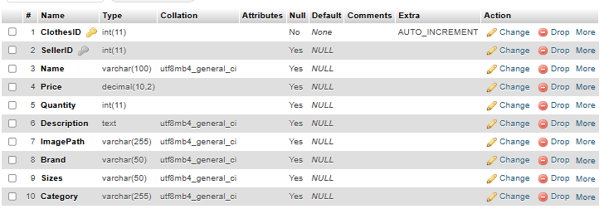

Figure 2:Table Structure of tblClothes

## Table structure for table tblmessages

|  |  |  |  |
| --- | --- | --- | --- |
| **Column** | **Type** | **Null** | **Default** |
| ***MessageID*** | int(11) | No |  |
| SenderID | int(11) | No |  |
| ReceiverID | int(11) | No |  |
| MessageText | text | No |  |
| Timestamp | datetime | Yes | current_timestamp() |

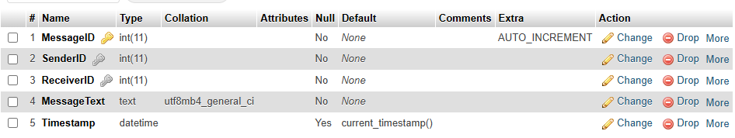

Figure 3:Table Structure of tblMessages

## Table structure for table tblorder

|  |  |  |  |
| --- | --- | --- | --- |
| **Column** | **Type** | **Null** | **Default** |
| ***OrderID*** | int(11) | No |  |
| UserID | int(11) | No |  |
| Username | varchar(50) | No |  |
| ClothingName | varchar(255) | No |  |
| Quantity | int(11) | No |  |
| Price | decimal(10,2) | No |  |
| TotalPrice | decimal(10,2) | Yes | NULL |
| OrderDate | datetime | Yes | current_timestamp() |

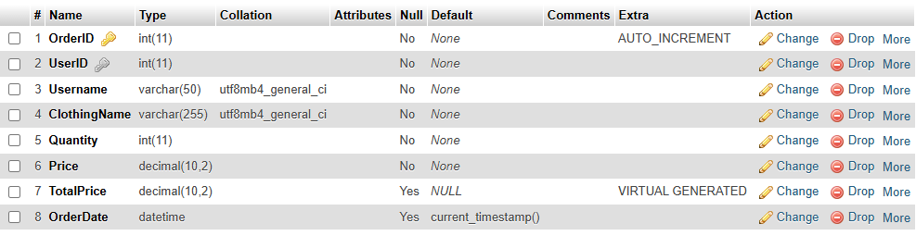

## Dumping data for table tblorder

|  |  |  |  |  |  |  |  |
| --- | --- | --- | --- | --- | --- | --- | --- |
| 1 | 1 | jdoe | Black Dress | 1 | 499.99 | 2024-11-10 18:58:35 | 499.99 |
| 2 | 1 | jdoe | Beige Women Coat | 1 | 899.99 | 2024-11-10 19:23:46 | 899.99 |
| 3 | 1 | jdoe | Blue Dress | 1 | 599.99 | 2024-11-10 19:28:35 | 599.99 |

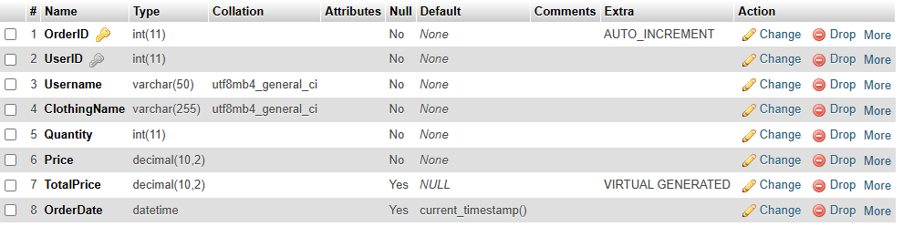

Figure 4: :Table Structure of tblOrder

## Table structure for table tblorderitems

|  |  |  |  |
| --- | --- | --- | --- |
| **Column** | **Type** | **Null** | **Default** |
| ***id*** | int(11) | No |  |
| order_id | varchar(255) | No |  |
| item_name | varchar(255) | No |  |
| item_price | decimal(10,2) | No |  |
| item_quantity | int(11) | No |  |

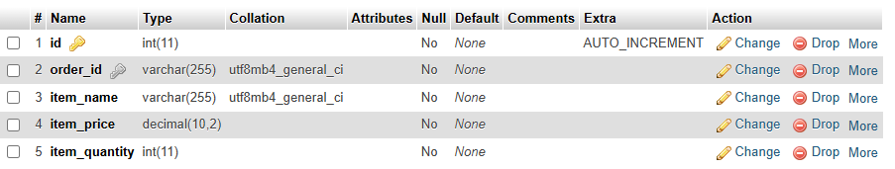

Figure 5: Table Structure of tblOrderItems

## Table structure for table tblorders

|  |  |  |  |
| --- | --- | --- | --- |
| **Column** | **Type** | **Null** | **Default** |
| ***order_id*** | varchar(50) | No |  |
| user_id | varchar(50) | Yes | NULL |
| seller_id | varchar(50) | Yes | NULL |
| session_id | varchar(50) | Yes | NULL |
| total_amount | decimal(10,2) | Yes | NULL |
| order_date | timestamp | No | current_timestamp() |

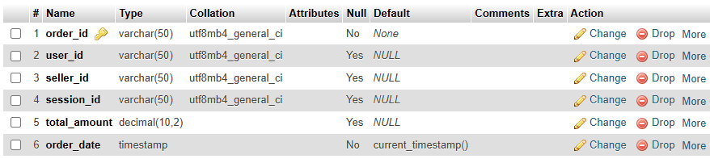

Figure 6: Table Structure of tblOrders

## Dumping data for table tblorders

|  |  |  |  |  |  |
| --- | --- | --- | --- | --- | --- |
| order_673107838f06c | 1 | N/A | opgi3qo8eim9ga8m37rkavd6uu | 0.00 | 2024-11-10 21:20:35 |
| order_6731078711f00 | 1 | N/A | opgi3qo8eim9ga8m37rkavd6uu | 0.00 | 2024-11-10 21:20:39 |
| order_6731078aaa3bb | 1 | N/A | opgi3qo8eim9ga8m37rkavd6uu | 0.00 | 2024-11-10 21:20:42 |
| order_6731086000bba | 1 | N/A | opgi3qo8eim9ga8m37rkavd6uu | 899.99 | 2024-11-10 21:24:16 |
| order_673109514cb7d | 1 | N/A | opgi3qo8eim9ga8m37rkavd6uu | 0.00 | 2024-11-10 21:28:17 |
| order_67310983e074e | 1 | N/A | opgi3qo8eim9ga8m37rkavd6uu | 599.99 | 2024-11-10 21:29:07 |

## Table structure for table tblseller

|  |  |  |  |
| --- | --- | --- | --- |
| **Column** | **Type** | **Null** | **Default** |
| ***SellerID*** | int(11) | No |  |
| Username | varchar(50) | No |  |
| Email | varchar(100) | No |  |
| Password | varchar(255) | No |  |
| SellerName | varchar(100) | Yes | NULL |
| ContactNo | varchar(15) | Yes | NULL |
| Address | text | Yes | NULL |
| isApproved | tinyint(1) | Yes | 0 |
| DateJoined | timestamp | No | current_timestamp() |

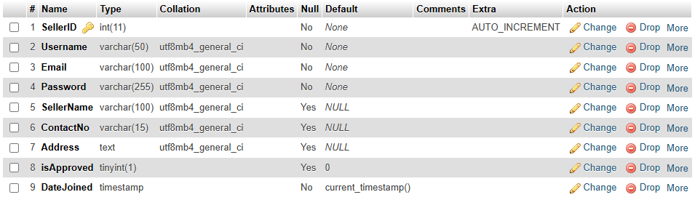

Figure 7: Table Structure of tblSeller

## Dumping data for table tblseller

|  |  |  |  |  |  |  |  |  |
| --- | --- | --- | --- | --- | --- | --- | --- | --- |
| 1 | seller1 | seller1@example.com | $2y$10$BCHCCidCWlyZhP12c6rW7e7nNozftWKUIHb5xGrvYWiLKUakjqhcm | Alice Johnson | 1234567890 | 123 Main St, Cityville | 0 | 2024-10-28 06:22:12 |
| 2 | seller2 | seller2@example.com | $2y$10$LqSPQbzfD4MqLxJstHTlYejLaozp2IT5QxW87Re13nMJS90lzgltO | Bob Smith | 2345678901 | 456 Elm St, Townsville | 0 | 2024-10-28 06:23:44 |
| 3 | seller3 | seller3@example.com | $2y$10$qgO6Se26UIwW5M7URx.hL.N5tqq3ATlizGeLZ6P8jliHudMI4ZAH6 | Carol Davis | 3456789012 | 789 Maple Ave, Villageburg | 0 | 2024-10-28 06:24:29 |
| 4 | seller4 | seller4@example.com | $2y$10$4UGi4Ta6JoGKNosLIa5v2.8WdxJKg1QED1LbCwUJsfOlpnIh0YOrO | David Wilson | 4567890123 | 101 Oak St, Hamletville | -1 | 2024-10-28 06:26:11 |
| 5 | demo | demo@gmail.com | $2y$10$NuDi.YhYkCLk3HCBjtx.0eKkBTHL/hmzx62miLh94p6EmbyZk6aQm | Demo | 1234567890 | Demo st | 1 | 2024-11-03 08:01:44 |

## Table structure for table tbluser

|  |  |  |  |
| --- | --- | --- | --- |
| **Column** | **Type** | **Null** | **Default** |
| ***UserID*** | int(11) | No |  |
| **Username** | varchar(50) | Yes | NULL |
| Name | varchar(100) | Yes | NULL |
| Surname | varchar(100) | Yes | NULL |
| Address | varchar(100) | Yes | NULL |
| **Email** | varchar(100) | Yes | NULL |
| PasswordHash | varchar(255) | Yes | NULL |
| isApproved | tinyint(1) | Yes | 0 |

## Dumping data for table tbluser

|  |  |  |  |  |  |  |  |
| --- | --- | --- | --- | --- | --- | --- | --- |
| 1 | jdoe | John | Doe | 123 Main St | j.doe@abc.co.za | $2y$10$QAilIQ7WHuhcBOeUGPlt/OTVFoXUNmHZmM2zB03FlQIHlGEDMBtBm | 0 |
| 2 | jsmith | Jane | Smith | 456 Elm St | j.smith@abc.co.za | $2y$10$Spp3DTqlvRdvAo0dp24pU.ULZLZfrBo.SXvfsvTswrtqcaD6vkoFe | 0 |
| 3 | mreed | Michael | Reed | 789 Oak St | m.reed@abc.co.za | $2y$10$sHCA82MT7i08fKdfP/gUVuzXPM3gCRYyfvLBJwylY2Gp/OsA9ouD6 | 0 |
| 4 | slee | Sarah | Lee | 321 Pine St | s.lee@abc.co.za | $2y$10$BHJj7.rX238zYeLaND1Zo.QgvLkGVajHMjjtYLsa6AOC4ojZdnxvq | 0 |
| 5 | dkim | David | Kim | 654 Maple St | d.kim@abc.co.za | $2y$10$XxP0VOc3HMQ9WYwhZ5MkweLplekHPb7sjNEXCT32QONyEPRPdjQj6 | 0 |
| 6 | awalker | Alice | Walker | 123 Oak St | a.walker@abc.co.za | $2y$10$ikMWJM8knkwZybgBGieuyemxgAMZBge2mYi0VSrckp0sn.UPZ1mjO | 0 |
| 7 | bmiller | Bob | Miller | 456 Pine St | b.miller@abc.co.za | $2y$10$R9Kz04GdnePUcKwoic80X.D2AKb76NH/fLfImnH63wVta1oJGeSUS | 0 |
| 8 | cjohnson | Charlie | Johnson | 789 Cedar St | c.johnson@abc.co.za | $2y$10$eu86GskI3OkBisdXvvhOAeXSfn9gs2Ne3W45wyLzVmzb50zfKSKQm | 0 |
| 9 | dgarcia | Diana | Garcia | 321 Maple St | d.garcia@abc.co.za | $2y$10$C24CbO.xj/6f/Rsocdhft.Xw6rs0FH8Y0gtcHbXkigLg8lEEpkDsG | 0 |
| 10 | emartinez | Evelyn | Martinez | 654 Elm St | e.martinez@abc.co.za | $2y$10$moAJWPOQRrHP.pku5EM.xeqXMZo.g3M1Nn3Nx2E3G.iu0JagKZnpm | 0 |
| 11 | fthompson | Frank | Thompson | 987 Birch St | f.thompson@abc.co.za | $2y$10$VtLXZ9fXv98LQouaDQw5c.eXQDxtzVH7WLU/6hIFj8rW1NsQTwO3W | 0 |
| 12 | gjones | Grace | Jones | 246 Walnut St | g.jones@abc.co.za | $2y$10$jsxYhmMs65nsvJLWwuHp7.MaDIlefScgY6zi3XUHHbPFn5yRRltpW | 0 |
| 13 | hwhite | Henry | White | 135 Ash St | h.white@abc.co.za | $2y$10$snKYwI9sIDJUsDx5oL0/IO2AIXOQT7EsbFXbO2dP/oKcM4kwx8jv. | 0 |
| 14 | ijones | Ian | Jones | 864 Willow St | i.jones@abc.co.za | $2y$10$0RLynfqxjA.1vgTimdSaO.2BdECnPRkV2p5LJKFi.Enfwc4IzSoe2 | 0 |
| 15 | jscott | Julia | Scott | 753 Maple St | j.scott@abc.co.za | $2y$10$kc3kCeY6FSD5xiOUKWkvS.0w72JSC3zp87qDHwrt6Gl7QTJZUaLli | 0 |
| 16 | kroberts | Karen | Roberts | 321 Cherry St | k.roberts@abc.co.za | $2y$10$T0hNKyiBeGN1AmCCF7KfuufQu.H6VQaV4U9fxr8wTp9vhTd6GO9tu | 0 |
| 17 | lking | Luke | King | 456 Pine St | l.king@abc.co.za | $2y$10$I/pIg7p0GNMiPyfAbEBqF.UgPillpHaaEdkcxMZt6c4iHSZBg0Ihi | 0 |
| 18 | mclark | Mary | Clark | 987 Spruce St | m.clark@abc.co.za | $2y$10$VDS2wkC586zQbxYYkxKcNOVr1vUcN/ypgiYv/Y8QIRuUYiorj.Ilu | 0 |
| 19 | nlewis | Nora | Lewis | 123 Palm St | n.lewis@abc.co.za | $2y$10$JZBaJYPzUUP.yYIlKetHHumy3ozRTE2uMEl5X3I3XsAetCmCbZ5kq | 0 |
| 20 | obrown | Oscar | Brown | 654 Fir St | o.brown@abc.co.za | $2y$10$p/2lOH.AdPfRg9VJlKmHde3kfhra4YBfmQC/.kzwTBdAfJW5hKOR. | 0 |
| 21 | pallen | Peter | Allen | 789 Spruce St | p.allen@abc.co.za | $2y$10$Ujq56noQpAkDArEggGrDUuyvch79g/Dq0XoX/eo.K1VIOzUjqKnES | 0 |
| 22 | qperkins | Quinn | Perkins | 246 Pine St | q.perkins@abc.co.za | $2y$10$c9uYpGhKrxMYHo5OFLqS1e21uL.wmEz93bj0agylIgSbIxA5j.55m | 0 |
| 23 | ryoung | Rachel | Young | 135 Cedar St | r.young@abc.co.za | $2y$10$Wb3yOmyD93oSMFpBieOixu2cGVqtkd57fxDYy9VihyNbxHsI/fGYW | 0 |
| 24 | sharris | Samuel | Harris | 864 Maple St | s.harris@abc.co.za | $2y$10$a/Z9ISyuCMh794nMez9tGOCUum/ltl1Dh65iyXdVIJAMYEvmfT9nO | 0 |
| 25 | tlee | Tina | Lee | 753 Oak St | t.lee@abc.co.za | $2y$10$prnGh0vjc9pq9SOAb5yAZOJZ0h4Pxh2EeIwHAy4ck.4kwepVgQsDG | 0 |
| 26 | udavis | Umberto | Davis | 321 Walnut St | u.davis@abc.co.za | $2y$10$ORBTrz1fOiNUpmBQv96tfu6.fWatESj3lpvhLrIpQxRdcY3paBH8u | 0 |
| 27 | vthompson | Vera | Thompson | 456 Ash St | v.thompson@abc.co.za | $2y$10$glfSP7.ukwlUOX/ITyI/s.bFaPyQXL2pqoQOs.1yiKM06R3xiTWO6 | 0 |
| 28 | wwilson | Walter | Wilson | 789 Birch St | w.wilson@abc.co.za | $2y$10$P8EbmbfFdTxYcmv9yDNW2u.2yxg/hFoFr.6GRmZU.ePB719W7.ifS | 0 |
| 29 | xmartin | Xena | Martin | 246 Cedar St | x.martin@abc.co.za | $2y$10$lqWaI0DlDFoObMzpzgqlfeLCXjkpA60GaSW1a.axNJFtNNy6Rx0xu | 0 |
| 30 | ygarcia | Yvonne | Garcia | 135 Elm St | y.garcia@abc.co.za | $2y$10$XQeNdI3r4WxQ/hwy3Pu5a.uvanNCgzmSCGkd0zaeKPihI.ZWTOV1S | 0 |
| 31 | zthompson | Zachary | Thompson | 864 Pine St | z.thompson@abc.co.za | $2y$10$qsDX8slbC5BqpXPfVmYFRewtPF9j611vvh3gabn1dGaSD7vIM4C4i | 0 |

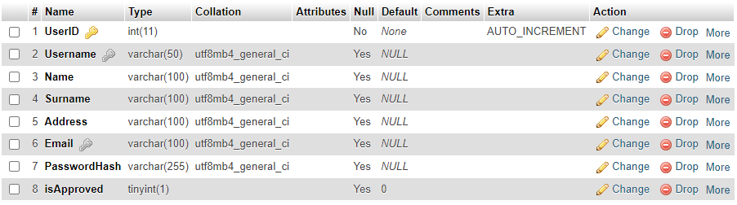

Figure 8:Table Structure of tblUser